**Apache Airflow – Theoretical Assessment**

**Introduction**

In modern data engineering, managing complex workflows, automating repetitive tasks, and ensuring data pipelines run reliably are essential. Traditional manual scheduling and script-based automation often fail to handle dependencies, retries, and monitoring efficiently.  
**Apache Airflow**, developed by Airbnb and later donated to the Apache Software Foundation, emerged as a robust solution to these challenges. It allows engineers to define, schedule, and monitor workflows programmatically using Python, ensuring scalability, transparency, and maintainability.

Airflow uses the concept of **Directed Acyclic Graphs (DAGs)** to represent workflows. Each workflow consists of tasks connected in a logical sequence, where the direction defines execution order, and the acyclic property ensures that there are no loops or circular dependencies.  
This report discusses Airflow’s core concepts, architecture, components, and real-world applications.

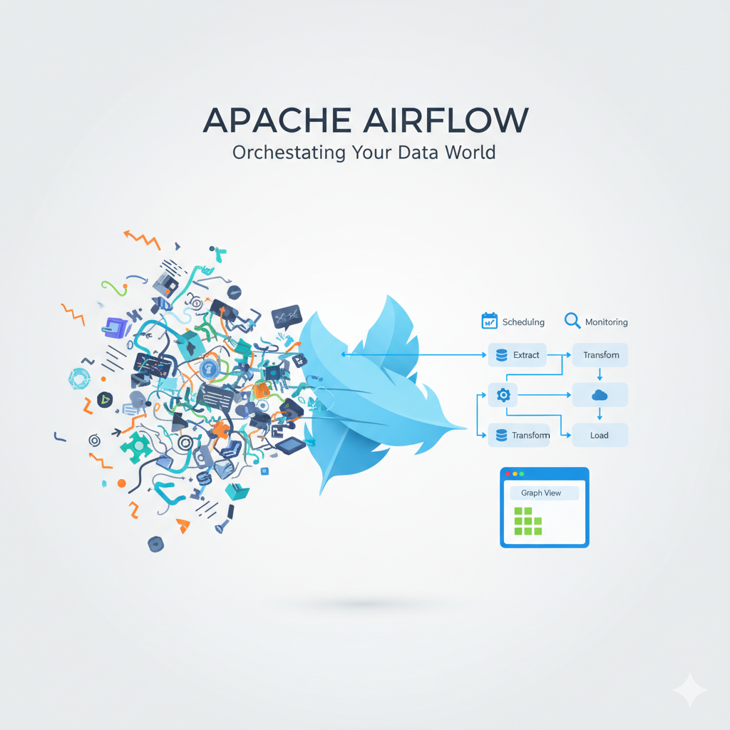

**Section A – Basics**

**1. Understanding Apache Airflow**

Apache Airflow is an **open-source platform** designed to orchestrate, schedule, and monitor workflows efficiently. It allows users to create workflows as code, enabling automation and version control. Airflow is written in Python, and its workflow definitions are also Python scripts, making it easy for developers and data engineers to integrate logic dynamically.

The primary purpose of Airflow is to **manage complex data pipelines**—for example, Extract-Transform-Load (ETL) processes, batch data processing, and machine learning model training workflows. It provides a web-based user interface for visualizing task execution, debugging failures, and tracking data lineage.  
Airflow’s extensible nature allows integration with multiple systems such as Hadoop, Spark, AWS, GCP, and databases.

Key advantages include:

* Centralized orchestration of workflows.
* Clear visualization of dependencies.
* Robust retry, logging, and alerting mechanisms.
* Modular and extensible architecture using operators and hooks.

**2. Concept of DAG (Directed Acyclic Graph)**

A **DAG**—short for **Directed Acyclic Graph**—is the backbone of Airflow. It represents the workflow structure that dictates how and when tasks should run.

* **Directed:** Each task points to another task that follows it, forming a directed path of execution.
* **Acyclic:** There are no circular dependencies, ensuring that tasks do not depend on themselves.
* **Graph:** The overall workflow is represented as a set of nodes (tasks) and edges (dependencies).

In Airflow, a DAG defines:

* The **schedule** of workflow runs.
* The **tasks** that must be executed.
* The **relationships** between those tasks.

This ensures workflows are executed in a predictable, controlled, and dependency-driven manner.

**3. Difference Between a DAG and a Task**

A **DAG** represents the entire workflow, while a **Task** is a single operation within that workflow. The DAG defines the order, timing, and dependencies, while tasks perform specific actions.

For example, in a data pipeline:

* The **DAG** defines the sequence — “extract → transform → load”.
* The **tasks** might include running a Python script to extract data, executing a SQL query to transform it, and uploading it to cloud storage.

This distinction allows Airflow to separate **workflow management (DAG)** from **task execution logic**, promoting modularity and clarity.

**4. Importance of “Directed Acyclic Graphs”**

The DAG structure is vital because it prevents circular dependencies, ensuring that tasks have a clear and logical order. If workflows were not acyclic, they could fall into infinite loops or conflicting dependencies.

The directed nature of the graph ensures:

* Tasks follow a defined order.
* Parallel and dependent executions can be clearly represented.
* The scheduler can easily determine which tasks are ready to run next.

This structure makes Airflow both **deterministic and reliable**, key qualities for data pipelines.

**Section B – Core Concepts**

**1. Major Components of Airflow**

Apache Airflow consists of four main components that work together to manage workflow execution:

**a) Webserver**

The **Webserver** provides the graphical user interface (GUI) for Airflow. It allows users to visualize DAGs, trigger runs, check task status, view logs, and manage configurations. It is the user-facing layer of the platform and is typically hosted on port 8080.  
Through the webserver, administrators can easily monitor workflow health and re-run failed tasks.

**b) Scheduler**

The **Scheduler** is responsible for monitoring all DAGs and determining when individual tasks should run, based on their schedule and dependencies. It continuously checks whether a task’s prerequisites are met and then queues it for execution by the worker.  
It is the **heart of Airflow’s orchestration** system, ensuring that every DAG runs as expected.

**c) Metadata Database**

The **Metadata Database** acts as the backbone of Airflow. It stores all configuration data, DAG definitions, task states, user information, and logs. Common databases like PostgreSQL or MySQL are typically used.  
This database ensures **state persistence**, meaning Airflow can resume operations and track historical runs even after restarts.

**2. Purpose of airflow db init Command**

When Airflow is installed for the first time, the command **airflow db init** initializes the metadata database. It creates all necessary tables and schema required for Airflow to function. Without initializing the database, the scheduler and webserver cannot operate, as they depend on this data to manage DAGs and task states.

This command must be executed once before the first use of Airflow.

**3. Significance of start_date and schedule_interval**

These two parameters define **when and how often** a DAG should execute.

* **start_date:** The timestamp indicating when the DAG’s first run should start. Airflow uses this date as a reference for scheduling future runs.
* **schedule_interval:** Defines the frequency of execution—daily, hourly, weekly, etc. It can be set using predefined presets like @daily, @hourly, or CRON expressions such as "0 12 * * *".

Together, these parameters allow precise control of workflow timing and recurrence.

**4. Role of catchup=False**

By default, if Airflow is down for some time, it tries to “catch up” on all missed DAG runs once restarted. Setting **catchup=False** prevents this behavior, ensuring that only the most recent run is executed.

This is particularly useful for:

* Real-time dashboards or streaming pipelines.
* Workflows that do not depend on past data.

Disabling catch-up avoids unnecessary processing and keeps the system efficient.

**Section C – Operators and Execution**

**1. Understanding Operators**

An **Operator** is the fundamental building block of Airflow’s tasks. It defines what action should be executed. Airflow provides many built-in operators, such as:

* **BashOperator:** Runs shell or bash commands.
* **PythonOperator:** Executes Python functions.
* **EmailOperator:** Sends automated emails.
* **SQL operators:** Execute SQL queries across various databases.

Each operator encapsulates logic for performing a particular type of operation, making workflows modular and reusable.

**2. Task Failures and Retries**

Airflow offers robust failure-handling capabilities. If a task fails, the system can automatically retry execution a specified number of times before marking it as failed.  
Configuration parameters include:

* retries: Number of retry attempts.
* retry_delay: Time interval between retries.

Additionally, Airflow can alert users through email or external monitoring systems. This ensures that transient issues, such as temporary network failures, do not halt the workflow entirely.

**3. XCom – Cross-Communication Between Tasks**

**XCom (short for Cross-Communication)** allows tasks to share small amounts of data between each other.  
For example, one task may extract a file path and “push” it to XCom, while another task “pulls” that value to perform transformations.

XComs are stored in the metadata database and enable **dynamic workflows** where output from one task can influence another.  
However, XComs are designed for small data exchanges—large datasets should be passed through external storage like databases or cloud buckets.

**4. BashOperator vs. PythonOperator**

The **BashOperator** executes shell commands, while the **PythonOperator** runs Python functions directly.

| **Feature** | **BashOperator** | **PythonOperator** |
| --- | --- | --- |
| Purpose | Execute bash/shell commands | Run Python code or functions |
| Use Cases | System tasks, file manipulation, script execution | Data transformation, custom logic |
| Example | bash_command='echo Hello World' | python_callable=my_function |

Both operators are widely used, and developers often combine them within the same DAG depending on the workflow’s requirements.

**Section D – Real-World Use and Best Practices**

**1. Airflow in ETL Workflows**

One of the most common applications of Airflow is **ETL (Extract, Transform, Load)** pipelines.  
For instance, a company may use Airflow to:

1. **Extract** data from APIs, CSV files, or databases.
2. **Transform** it using Python, Spark, or Pandas scripts.
3. **Load** the cleaned data into a data warehouse such as Amazon Redshift or Google BigQuery.

Airflow schedules this pipeline to run daily, ensuring consistent data availability for analytics. The monitoring interface allows data engineers to trace errors and re-run specific stages if necessary.

**2. Keeping DAGs Lightweight**

It is a best practice to keep DAG scripts lightweight. The reason is that the **Airflow Scheduler frequently parses all DAG files** to identify workflows and their dependencies. If these files contain heavy computations or data processing logic, it can slow down or crash the scheduler.

Instead, all heavy operations should be performed within the **tasks themselves** (i.e., inside Operators or Python functions), while the DAG file should only contain workflow structure and configurations.

**3. Importance of Unique dag_id**

Every DAG must have a **unique identifier (dag_id)** to avoid conflicts within the metadata database. If two DAGs share the same ID, Airflow will not be able to distinguish between them, causing scheduling errors or overwriting previous runs.  
Maintaining unique identifiers ensures proper organization, tracking, and execution of all workflows.

**4. Ensuring Correct Task Execution Order**

Airflow guarantees that workflows execute in the intended order by enforcing dependencies between tasks.  
These dependencies are defined using:

* set_upstream() and set_downstream() methods, or
* Shorthand operators like >> and <<.

For example:

extract_task >> transform_task >> load_task

This ensures that the **transform task** runs only after **extract** completes successfully.  
The scheduler strictly respects these dependencies, maintaining workflow integrity and preventing premature task execution.

**Conclusion**

Apache Airflow has become a cornerstone technology in modern data engineering and DevOps pipelines. Its flexibility, scalability, and modularity make it ideal for orchestrating complex workflows.  
By representing workflows as Directed Acyclic Graphs, Airflow ensures transparency, reliability, and ease of monitoring.

The understanding of its components—such as the webserver, scheduler, metadata database, and operators—enables developers to design efficient and fault-tolerant pipelines.  
When combined with best practices like keeping DAGs lightweight, assigning unique identifiers, and managing dependencies carefully, Airflow can automate virtually any workflow within an organization.